Planning

All deadlines are at 9:00 AM unless stated otherwise

Internal deadlines:

* 8-4-2022 draft poster (so that we can review it as a group and use the weekend for necessary changes)
* 14-4-2022 final poster finished (to again review it as a group and make changes)

Hard Deadlines:

* 11-4-2022 deadline draft poster
* 13-4-2022 deadline review another group
* 15-4-2022 final version poster done
* 20/21/22 -4-2022 project presentation

Subjects to put on poster

* Where to place storages in the factory, with relation to work in progress
* Optimization of the import and export storage sizes, maybe even including statistics
* Replacement parts inventory
* Protect against stock outs, while maintaining low reorder costs and small inventory space
* How to compensate to lead times and order costs
* Calculate economic order quantity and reorder point
* Calculate when to ship to ashdod and smaller customers (size of products versus size of trucks)
* Inventory levels (and the optimization of it)
* Maybe use economic batch quantity
* Safety stock
* Contents of lecture on warehousing
* Create Mathematical models to calculate revenue (profit per product, annual profit and Break-even period etc. taking into consideration scrap, rework etc.)

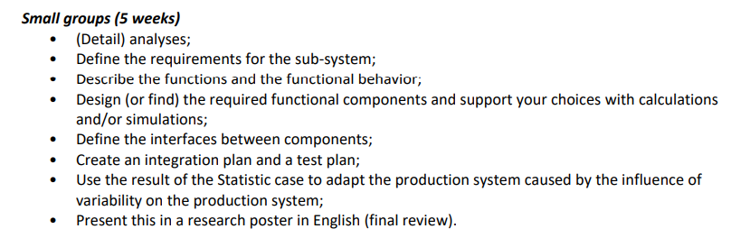

* Estimate the revenue generated by selling of parts according to the delivery requirement using the price of the produced goods mentioned.-robin

1. Calculate revenue based on information about part price and stock price
2. Calculate revenue from new production based on 25 cranes per month

* Make a financial model with the estimated revenue to predict the maximum affordable running cost of the Production System -marco

1. Based on the estimated revenue calculate how much money we are able to spend and on which departments.

* Handles cost estimation (preparation costs, assembly costs, machine hourly rate, manufacturing costs, material costs, machine costs, labor costs, tooling costs etc…) - Philip

* Handles ordering of materials (EOQ and ROP) estimation (inventory control)
* Warehousing (storage of inventory) (private, order fulfillment, layout of warehouse in the floorplan) (related to the above point)